Python training manual for C4T mentors

1. Download and setup Python 3.x.x
   1. Go to <https://www.python.org/>
   2. Select and download latest version.
   3. On the first screen, enable the “Add Python 3.x to PATH” option to run python on terminal and then click “Install Now.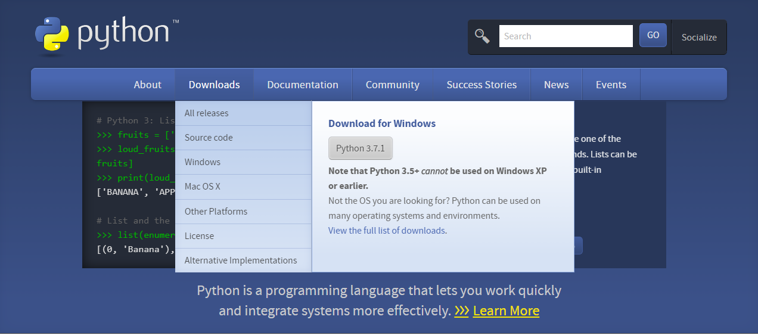
   4. When the setup finish, open command prompt (or terminal) run “python”, you should get output like this. Now you can code or program in python 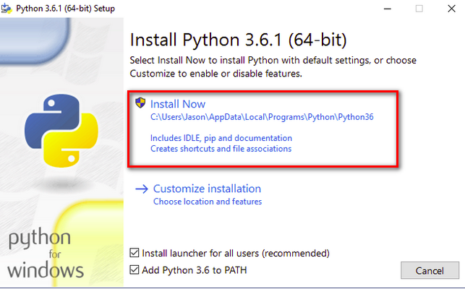

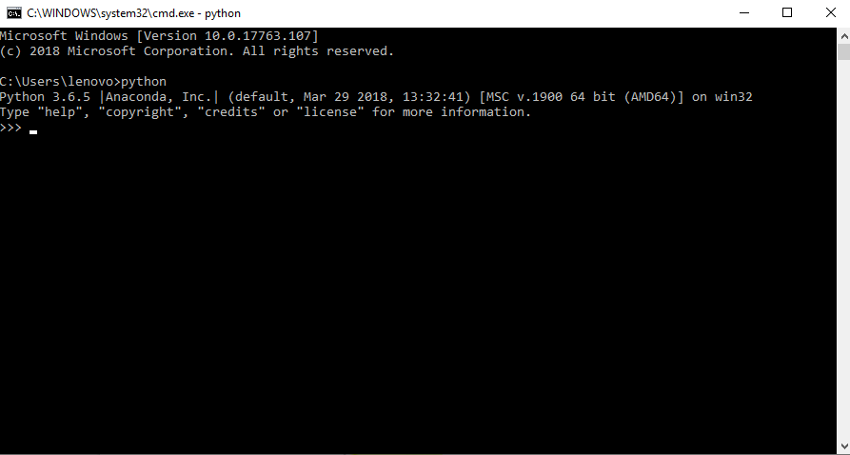

1. Install code editor
   1. Go to <https://code.visualstudio.com/>
   2. Download and install latest version
   3. Run a python file
      1. Open a folder and create a new file with filename like this: ***.py
      2. Write some line of python code (ex: print(“..”), etc) - remember to save the file by press ctrl + s
      3. Press “ctrl + ~” to open the terminal in vscode
      4. Run “python *your python file name*”

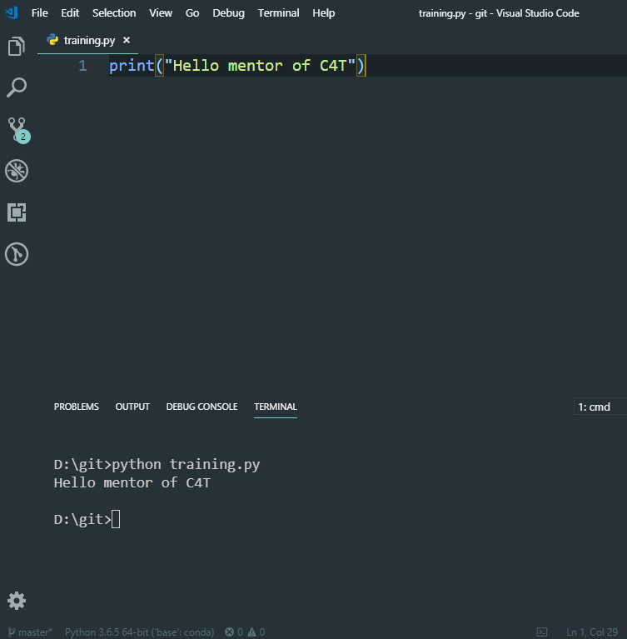

1. Python roadmap for C4T mentors

Learning source:

* [Python book](http://www.ict.ru.ac.za/Resources/cspw/thinkcspy3/thinkcspy3.pdf)
* [Python video packs](https://learn.techkids.vn/)
  + Sign in with account: **mentor.techkidsvn / codethechange**
  1. Variable:
     1. Read chapter 2 of the book above
     2. Practice
  2. Loop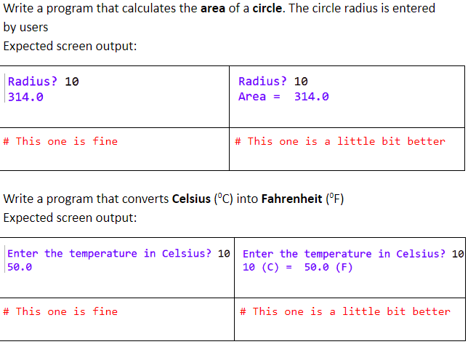
     1. Read chapter 7 **OR**
     2. Watch below playlist with above account
     3. Practice: 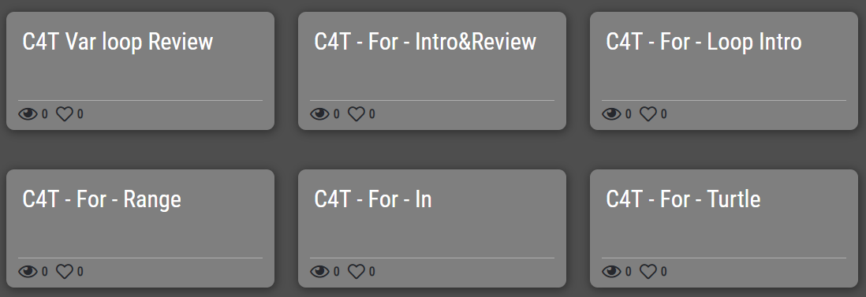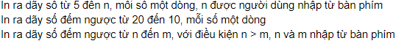
  3. Conditional 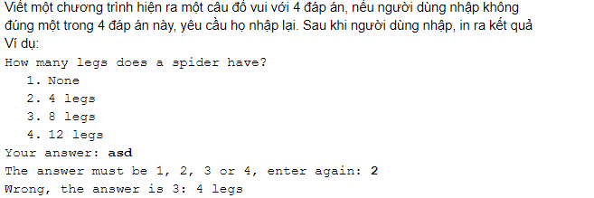
     1. Read chapter 5 **OR**
     2. Watch these playlist
     3. Practice: 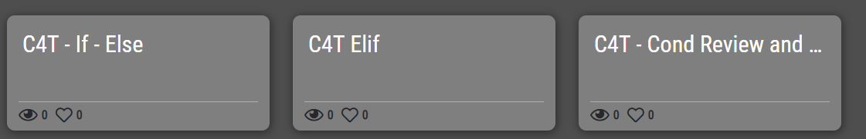
  4. List 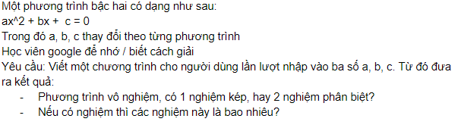
     1. Read chapter 11 **OR**
     2. Watch these playlist
     3. Practice: 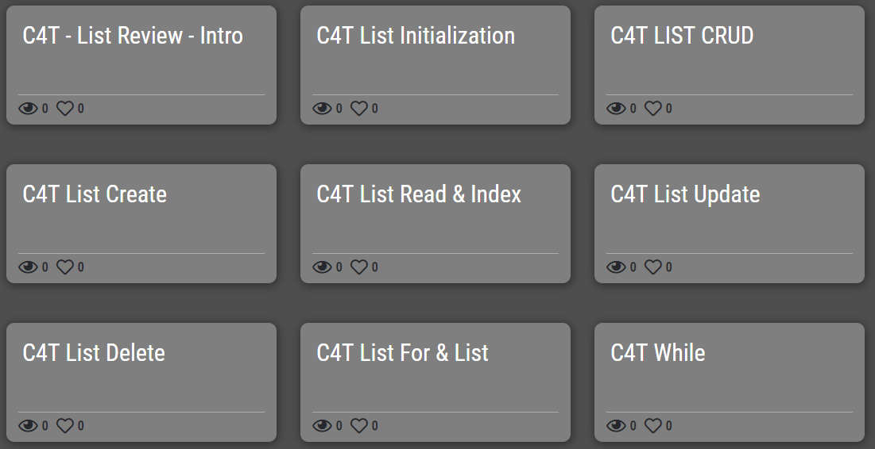
  5. Dictionary 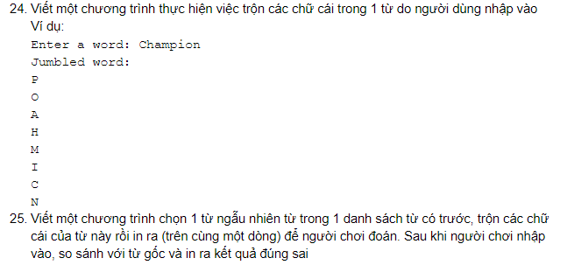
     1. Read chapter 20 **OR**
     2. Watch these playlist
  6. Exercise: 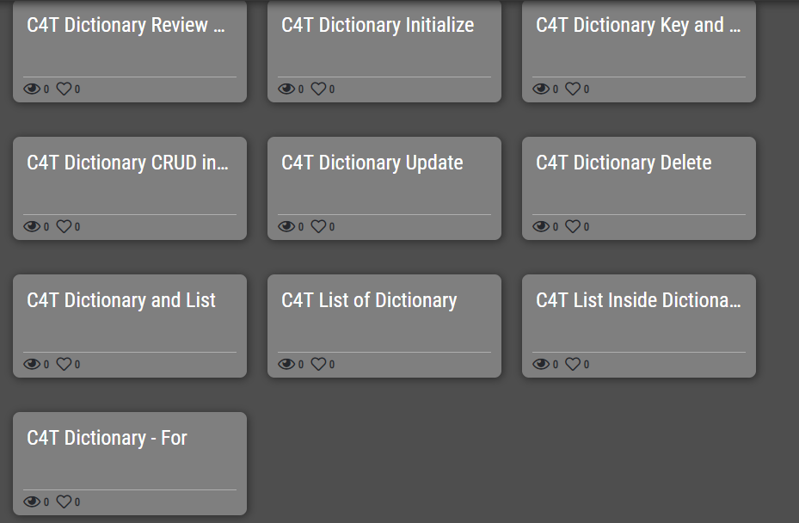
     1. Watch this [demo video](https://learn.techkids.vn/playlist/5bc1ddea4683ebdacf83f0e4/5bc1ddea4683ebdacf83f0e3)
        + Write a program have same features as the above video
        + Tools requirements:
          1. [Youtube_dl module](https://github.com/rg3/youtube-dl/blob/master/README.md#readme)
          2. [Pyglet](https://gist.github.com/qhuydtvt/7f9d33b67bc048057060a67ad9e267ad) - remember to run *pip install pyglet* first
          3. [avbin](https://drive.google.com/file/d/1omO2rnV-6HlyOTYeJhkMRMZLZnQjSTa3/view)
          4. [FFmpeg](https://ffmpeg.zeranoe.com/builds/) / [install manual](https://www.wikihow.vn/C%C3%A0i-%C4%91%E1%BA%B7t-FFmpeg-tr%C3%AAn-Windows)
     2. Complete all exercises in this [link](https://docs.google.com/document/d/11tSauKLHnmyNBa7v0ER_lx5I_lXs3Pcx5_cJ8hrG4sE)
     3. Send the source code files or git repo link to gmail: **minhduc.096.99@gmail.com** and cc to **tranphuongha2@gmail.com**,
  7. More advance python
     1. Function (chapter 4 and 6)
     2. Python modules (chapter 12)
     3. Class in python (chapter 15, 16)